**Group Assignment: Mountain Man Brewing Company (MMBC)**

**Question 1 (5 points)**

MM light is horizontal line expansion because it is the same product but with different taste, and therefore, it depends mainly on the person's preference rather than the price.

The advantages are to offer a better match with our customer needs and preferences, to increase market share or market power by leveraging existing assets, to increase differentiation, and to give MM the ability to enter new markets. It can also capture a new, younger customer base and make a second leap by producing products in the same direction as the market trend. It also creates economies of scale.

The disadvantages are that you can get cannibalization of your existing product, because horizontal expansion does not expand our segment. It might also increase some of the company costs (inventory, packaging, SG&AE). Launching the light beer can affect the brand image and might lose some of the loyal customers as they care about the aura of authenticity.

**Question 2 (15points)**

|  |  |  |
| --- | --- | --- |
|  | **MM Light** | **MM Lager** |
| **Positioning Statement** | For first-time beer drinkers, MM light is the brand of light beers offer regional reputation because MMBC is running the business from the past 50 years and MMBC is the only one for this market in the region. | For blue-collar, middle to lower-income men over age 45, MM lager is the brand of traditional beers that has a bitter flavour and slightly higher alcohol content because MMBC is running the business from the past 50 years and MMBC is the only one for this market in the region. |
| **Customer Profiles - Why** | Light beer is a new trend | Appreciate authenticity |
| **Customer Profiles - What** | Follow new trend | Follow conventional habit |
| **Customer Profiles - Who** | First-time beer drinkers who are aged between 21 to 27 | Blue-collar, middle to lower-income men over age 45 |

**Question 3 (40 points)**

|  |  |  |
| --- | --- | --- |
| **Question**  [Assumption] | **(1 ) and (2)**  [5 % will be lost] | **(3)**  [20% will be lost] |
| **Total Revenue ($)** | 50,000,000 | |
| **Quantity (unit)** | 520,000 | |
| **Price per Barrel ($)** | 97 | |
| **Variable Cost ($) - Lager** | 66.93 | |
| **Variable Cost ($) - Light** | 71.92 | |
| **Contribution ($)**  [(revenue per barrel – variable cost per barrel) × number of barrels sold] | [(50,000,000 - 66.93) x 520,000]  = 15,636,400 | |
| **Loss of Contribution ($)** | 781,820 | 3,127,280 |
| **Extra Quantity to Recover (unit)** | 30,805 | 123,218 |

|  |  |
| --- | --- |
| **Break-even rate of cannibalization (BERC)**  [Margin New ÷ Margin Old] | [97 – (66.93+4.69)] **÷** (97 – 66.93)  = 84.4% |
| **Break-even quantity to recover fixed cost**  [Fixed cost ÷ (Unit price - Unit cost)] | (750,000 + 900000) **÷** [97 – (66.93+4.69)]  = 65,012 units |
| **Total Quantity must be sold to recover the loss**  [MM Lager lose 5% sales]  [Total Loss ÷ (Unit price - Unit cost)] | [(781,820 + 750,000 + 900,000) ÷ (97 - 71.92)]  = 95,816 units |

**Question 4 (40 points)**

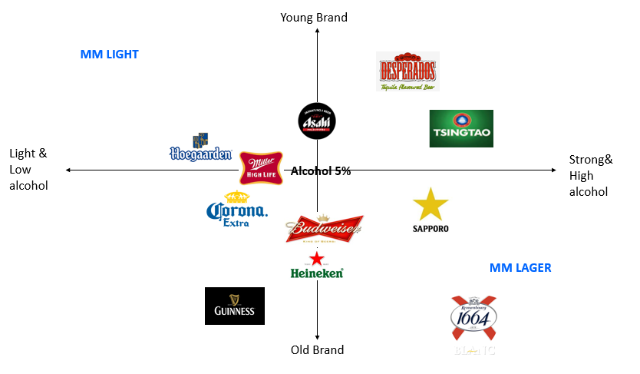Positioning Map:

Considering the fierce competition of the beer market in Korea, imported beers tend to compete with imported beers as the local beer brand has strong market power among Koreans. Reflecting the real market condition, we have positioned MMBC brands with other imported brands only. Based on the perception map and Korean market, we have decided that to launch MM Light in South Korea.

Customer Profile:

* Why?: Light beer is less harmful to health than stronger beers. Nowadays, it is trendy to take care of yourself and have a healthy lifestyle.
* What?: People who drink light beer are more open to imported and new brands.
* Who?: Mostly educated people in Korea, especially living in cities, between 18 and 40 years old who want to follow social trends, especially people who use social media (Instagram). And people who are starting to drink beer and are not used to strong flavour.

Positioning Statement:

For educated people living in cities in South Korea between 18 to 40 years old who use social media and follow social trends, MM Light is the brand of light beers that delivers distinctively light flavour with low calories and low alcohol content, which makes it less harmful for health but still make consumer to keep up with trend, because MMBC has a quality manufacturing process which has been operated for more than 50 years and has good reputation in US.

|  |  |  |  |  |  |  |
| --- | --- | --- | --- | --- | --- | --- |
| Population | Segment Size | Segment Penetration | Usage rate (beers per year) | Unit Price (KRW) | Unit Contribution | Segment Value |
| 55,000,000 | 15% | 1% | 100 | 5,000 | 18% | 7,425,000,000 |

|  |  |
| --- | --- |
| South Korean Population | Google |
| Segment size (%) | 26 % is the percentage of the population who are aged between 18 and 40. Therefore, because we are focusing on the educated people of this age range who like social media, we have assumed 15%. (Source: http://kosis.kr/statisticsList). |
| Segment Penetration  (%) | Assuming only 1% because we are focussing mostly in loyal customers and most Koreans will prefer local brands or competitors as Corona. |
| Usage rate (beers per year) | 148 is the average of drinking beers per year. We have assumed less than that to consider people purchasing other drinks/brands. |
| Unit Price (KRW) | Google |
| Unit contribution (%) | Webpage: dart.fss.or.kr |